1. Created a new angular app
2. Removed all the boilerplate code from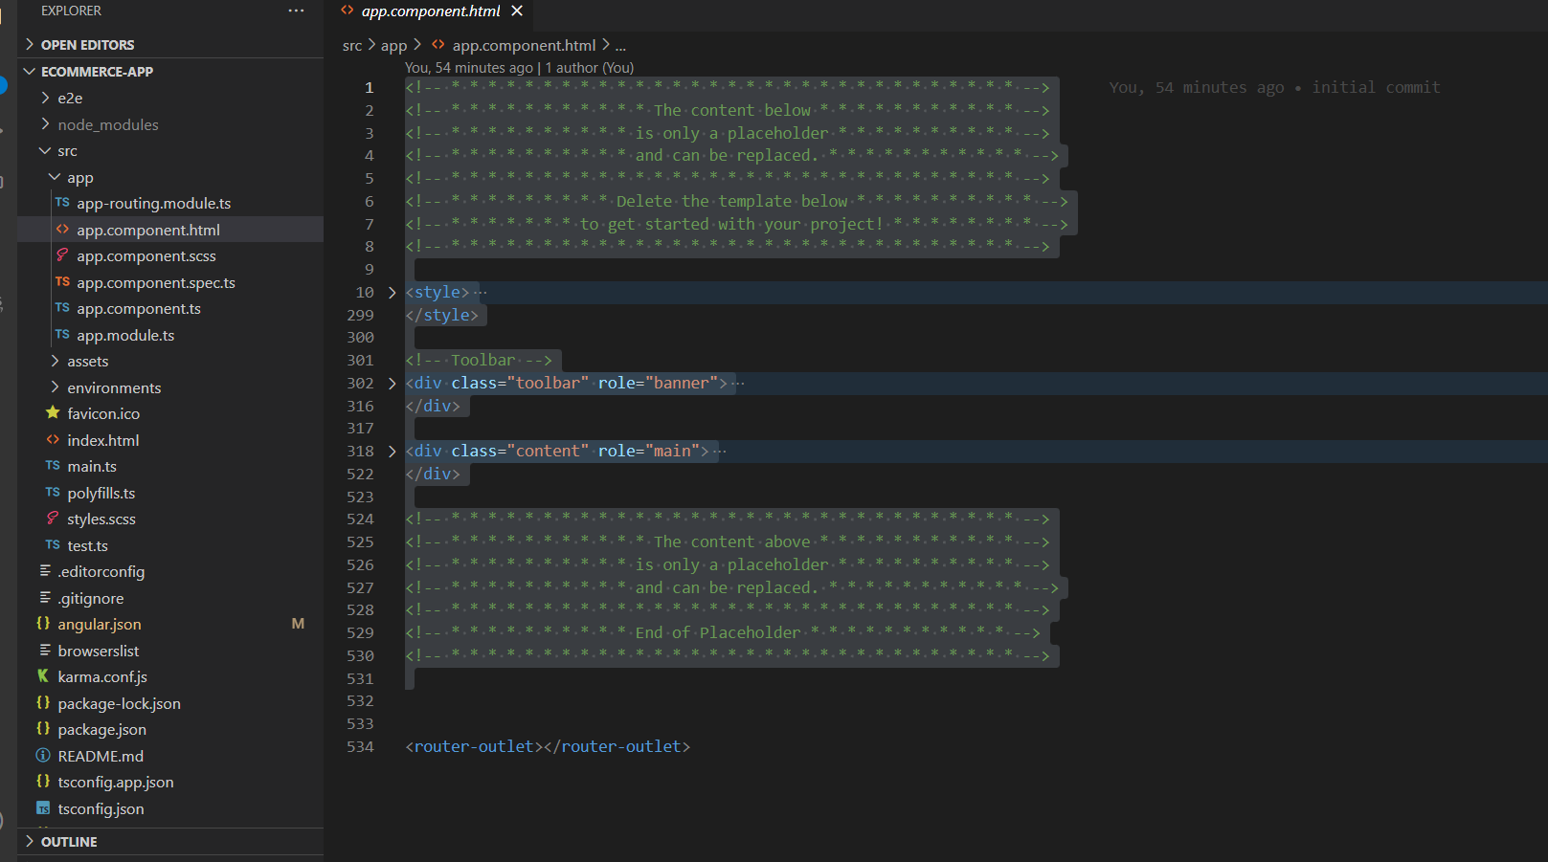
3. Created 2 folders -> Components, Services
4. Created Login component inside components folder
5. HTML is not supported by codewhisperer, so sed chatgpt to generate login form A screenshot of a computer program

   Description automatically generated
6. Creating login form components according to html file nowA screen shot of a computer

   Description automatically generated
7. Added comment first and letting code-whisperer complete the code belowA screenshot of a computer program

   Description automatically generated
8. Added a registration form link at the end of the login page, which registers new usersA screenshot of a computer

   Description automatically generated

1. If login is successful, redirect to products page, after adding the comment, code whisperer recommending correct codeA screen shot of a computer program

   Description automatically generated
2. Routing file

1. Taking the recommendation of code-whisperer and will create a new products moduleA screenshot of a computer program

   Description automatically generated
2. Creating registration form A screen shot of a computer code

   Description automatically generated
3. Redirect to login if successful  
     
   A screen shot of a computer program

   Description automatically generated

1. Generated products explore page with chatGPTA screenshot of a computer

   Description automatically generated

1. Generating component code using code whisperer

